# LAPTOP REQUEST CATALOG ITEM IN SERVICENOW

## Project Description

The project aims to design and implement a dynamic Laptop Request Catalog Item using ServiceNow. This catalog item will allow employees to easily request laptops for work while ensuring data accuracy, workflow automation, and approval tracking. The system will include features such as dynamic form behavior, reset functionality, approval workflows, automated notifications, and audit tracking. Using ServiceNow’s catalog builder and flow designer, this solution will replace the manual process with an efficient, user-friendly digital form. The goal is to streamline laptop requests and improve transparency and governance in IT asset allocation.

## Project Flow

* Milestone 1: Setting up ServiceNow instance.
* Milestone 2: Creation of new update set.
* Milestone 3: Creation of Laptop Request Catalog Item.
* Milestone 4: Adding variables
* Milestone 5: Configuring Catalog UI Policies.
* Milestone 6: Designing Flow for Approval and Notifications.
* Milestone 7:Exporting Changes to another instance
* Milestone 8: Retrieving the updated set
* Milestone 9: Conclusion.

## Milestone 1: Setting Up ServiceNow Instance

Sign up for a developer account on the ServiceNow Developer site (https://developer.servicenow.com). Request a personal developer instance, log in using the credentials provided, and navigate to your instance. Ensure you have admin access to create catalog items and flows. 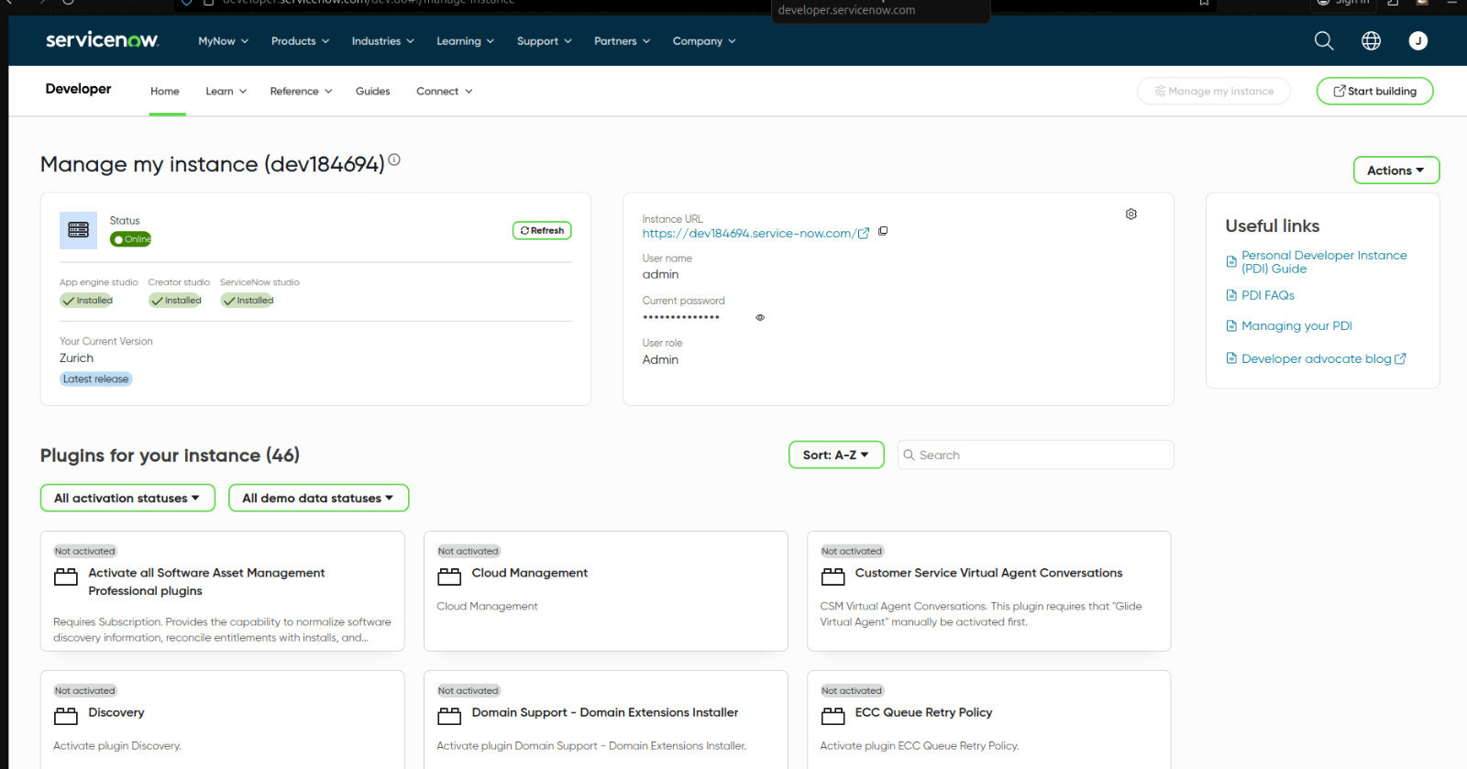

## Milestone 2: Creation Of New Update Set

Navigate to All >> System Update Sets >> Local Update Sets >> New.  
Enter the details:  
Name: Laptop Request Catalog Item  
Click Submit and make it the current update set to track your development changes.

## Milestone 3: Creation Of Laptop Request Catalog Item

Go to Service Catalog >> Catalog Definitions >> Maintain Items >> New.  
  
Enter the following details:  
Name: Laptop Request  
Catalog: Service Catalog  
Category: Hardware Requests  
Short Description: Request a new laptop for official use.  
  
Click Submit and then open the item again to start form customization.

Add variables for user input:  
• Employee Name (Type: Reference - User Table)  
• Department (Type: Reference - Department Table)  
• Laptop Type (Type: Select Box - e.g., Standard / High-Performance)  
• Storage Option (Type: Select Box - e.g., 256GB / 512GB / 1TB)  
• Additional Accessories (Type: Checkbox)  
• Justification (Type: Multi-line Text)  
Save the catalog item after adding all variables.

## Milestone 4: Adding Dynamic variables

Navigate to Service Catalog >> Catalog Client Scripts >> New.  
Configure the script to show or hide specific fields dynamically based on user selections.  
  
For example, if Laptop Type = High-Performance, display a new field for 'Manager Approval Reason'.  
Use the script type 'onChange' to trigger field visibility changes.

## Milestone 5: Configuring Catalog UI Policies

Go to Service Catalog >> Catalog UI Policies >> New.  
Add conditions to make certain fields mandatory or read-only based on other selections.  
  
Example:  
If 'Additional Accessories' is checked, make the 'Justification' field mandatory.  
This ensures that users provide a valid reason for additional requests.

## Milestone 6: Designing Flow For Approval And Notifications

Go to Flow Designer >> New >> Flow.  
Name: Laptop Request Workflow.  
  
Trigger: When Catalog Item 'Laptop Request' is submitted.  
Add actions:  
1. Create Approval - Send to user’s manager.  
2. Send Email Notification - Confirm receipt and approval outcome.  
3. Update Record - Assign task to IT fulfillment team once approved.  
Save and activate the flow.

## Milestone 7: Exporting changes to another instance

* Click on All >> search for update sets
* Select local update set
* Select created update set i.e. ‘Laptop Request Project’
* Set the state to ‘Complete’
* In the related list Update tab, updates are visible which we perform under this update set.
* Click on export to XML ,it download one file

## Milestone 8: Retrieving the Updated set

1. Open another instance in incognito window
2. Login with credentials
3. Click on all>> search for update sets
4. Select “Retrieved update set” under system update set
5. It open retrieved update set list and scroll down
6. Click on Import update set from XML
7. Upload the downloaded file in XML file
8. Click on Upload and it gets uploaded.
9. Open retrieved update set ‘laptop request project’
10. Click on preview update set
11. And click on commit update set
12. And also see the related tab updates
13. After commiting update set in this instance we get all updates which are done in the previous instance

## Milestone 9: Conclusion

The project 'Laptop Request Catalog Item in ServiceNow' successfully demonstrates the automation of the laptop request process. By leveraging ServiceNow’s catalog capabilities, client scripts, UI policies, and flow designer, the organization can replace the manual process with a dynamic and efficient digital solution. The added reset functionality, automated approvals, and audit tracking enhance user experience, reduce errors, and ensure governance. Overall, this project highlights the flexibility of ServiceNow in building intelligent service request systems.